Northern Secondary School Parent Council Meeting

January 10, 2017 at 6:30 p.m. in the Library

Present: Bettina Hoar, Jenn Marr, Ron Felsen, Nancy Matthews, Kaan Yigit, Tanya Goldeberg, Shellie Suter, Rachael Cayley, Peggy Judge, Steve Sims, Merhnaz Sekora, Kasi Kugapalan, Stefan Banjevic, Rob McCready, Adam Gordon, Jamshid Mortazavi, Judy Steiner, Scott deVeber, Melissa Rosen, Ethan Thompson, Karim Hajj,

Prepared by: Tanya Goldberg (volunteer)

Note: These are draft minutes that have not yet been approved by School Council and are hence potentially subject to change.

Agenda Item | Decision/Action Taken | Person Responsible
Welcome | - Approximately 20 parents attended plus Principal, Teacher reps and Student rep. Quorum was established.  - Mr. Felsen undertook to contact Ms. Bery (former SC Chair) to confirm her interest in Community Rep position. Item to be revisited at next meeting.  - No conflicts of interest declared. | Bettina
Caring Adult Program | - School has started “Caring Adult Program” which pairs Grade 9 students with adult mentor (teacher or staff member) they can turn to if problems. About 50 students identified as “at risk” based on info from previous school. Mentors have received training in how to provide support and receive info on student attendance and achievement. Frequency and content of meetings is determined consensually. Positive student response so far. Mentors will check in with students after February report cards issued.  - Teachers thank Council for sponsoring Lunch and Learns and the lunch for the Caring Adult program.  - Guidance thanks Council for providing financial support to students for post-secondary applications. | Christine Laurin  Gillian Evans
Budget Committee | - Updated budget report was provided.  - Motion to increase funding for Breakfast Club to $3000 (was previously approved at $1000) was carried with none opposed and no abstentions.  - Request for funding from People of Colour (POC) Club was discussed and deferred to next meeting. Club wishes to produce a student zine. Has been asked to speak with teacher advisers for Epigram (newspaper) and Rover (literary and arts magazine). Mr. Felsen pointed out that any new club must find a staff adviser and create a club charter before requesting funding.  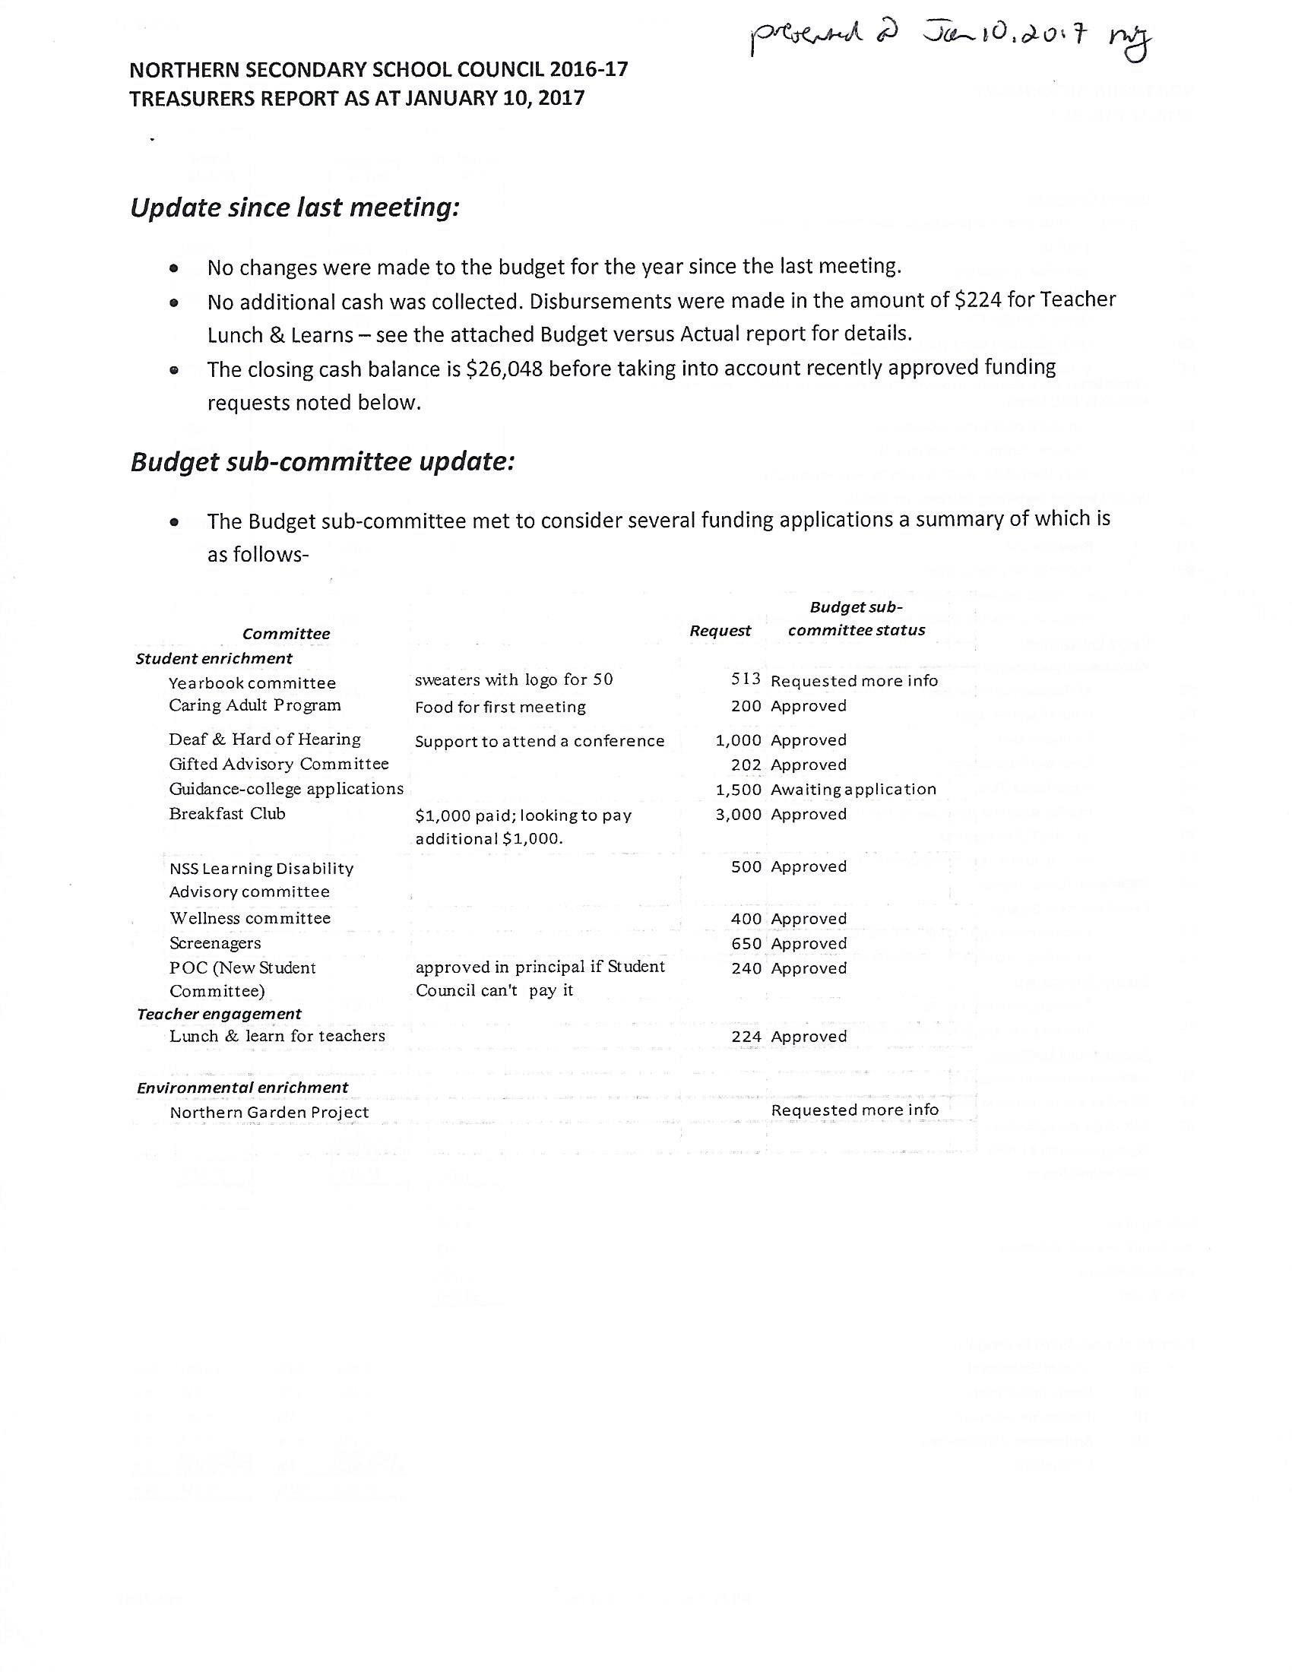 | Steve  Moved by: Peggy  2nd by: Rob  Carried
Cellphone Committee | - Committee has working drafts of surveys for teachers, students and parents to solicit input. Hope to get survey results by March so likely not actionable until next year. | Scott
Eco Committee | - Working with NEMO on ecogarden project. Request for funds but need full accounting for water bottles first. | Bettina
Wellbeing Committee | - Has accomplished 2 goals so far: 1) updated mental health resources list and 2) thanks to Irene Andrianopolitis, initiated ``quiet lunchroom`` for students who find cafeteria overwhelming.  - Tanya met with WellNSS and suggested topic (how to speak to your child about mental health) for January 25th parent evening. [Note: “How to Talk with your Teenagers about how they’re Managing” panel discussion on January 25 at 7 p.m.]  - Guidance gave Grade 12 students tips on how to manage post-secondary planning anxiety last semester. | Tanya
Learning Disabilities Committee | - Looking at technology supports for LD students.  - Hopes to schedule parent info night on My Blueprint before next course selection due date. [Note: subsequently scheduled for Feb 13 at 7:30 pm in room 310].  - Parents can also schedule appointment with Guidance any time or speak with their child’s teacher(s) on February 16 (teacher interview day) to discuss their child’s course selection. | Shellie
Gifted Advisory Committee | - Motion re size of Northern gifted program and admission process was presented, discussed and deferred to next meeting. Concern is that reduction of size below 120 students per year may impact Grade 11 and 12 elective course offerings. Currently there are 108 Grade 9 students although 122 initially registered. Course selection sheets are due March 1.  - Mr. Felsen undertook to determine: 1) the number of gifted siblings of current Northern gifted students who were denied admission to Northern as well as 2) the number of gifted students at Northern in Grade 9 who are not in the gifted program  - It was pointed out that the TDSB controls the admission process and recommendations to the Principal (and their response) must be presented to the Trustee and Superintendent.  - GAC asked to reconsider motion and recirculate it to Council in advance of February 13 meeting.  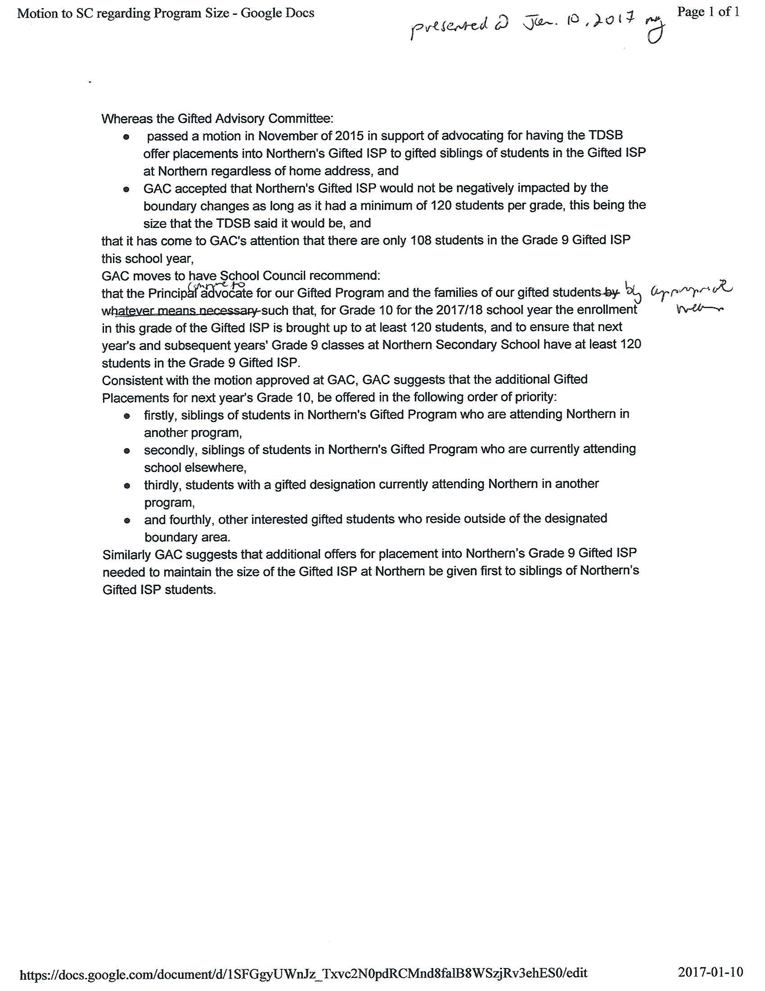 | Peggy
Welcome Committee | - Goals are to 1) prepare info to welcome new parents, 2) support existing parents (post FAQ on website, host panel discussion) and 3) update and expand Council website.  - Mr. Felsen undertook to send Rachel access to the info package prepared for Victoria Park parents. | Rachel
Breakfast Committee | - Things are going well with the snacks provided by Dale.  - Additionally Mr. Felsen pointed out that needy students are provided with cafeteria tickets for breakfast and lunch through the Toronto Foundation for Student Success program. | Bettina (for Barb)
Caring & Safe Schools Committee | - Request from teachers for ventilation fans during warmer months.  - Seeing an increase in drugs esp. marijuana this year. Students caught involved with drugs are suspended.  - Also increase in theft of cellphones and wallets. Discussion about security in changing rooms during gym class. Mr. Felsen undertook to discuss this issue further with the gym teachers. Issue to be revisited at next meeting. | Jamshid
Teachers’ Report | - Motion to approve $2500 funding to Buddies for retreat was carried with none opposed and no abstentions.  - Tiffany is meeting with Ministry of Education to ask that ASL be recognized as a language credit.  - Request from teachers for blinds and plants in classrooms. Mr. Banjevic to report back number(s) requested at next meeting. | Stefan Banjevic  Moved by: Bettina  2nd by: Scott  Carried
Student’s Report | - Pajama day this Friday and every Friday this month.  - Screenagers movie to be shown to students on Friday. [Note: after feedback from parent screening on Jan 12, Screenagers will now be shown to all students on Jan 19 during assembly.] | Ethan Thompson
Principal’s Report | - Ms. Kulendran promoted to Principal at another school; new VP is Eric Halling.  - Timetable Revision Committee is looking at: 1) whether to switch to semestered system, 2) start and end times for school day and 3) whether start school 1 week earlier and take 1 week November break.  - Re semesters: This is school choice, determined by staff vote. Staff are currently divided. Voted “no” 8 years ago. Will be 18 month time lag to implementation if vote “yes”.  - Have made proposal to Ministry for specialist high school major in transportation/auto shop. This is package of courses that constitutes certification training.  - Grade 8 Welcome Evening is January 19 at 6 p.m. Email SC.NorthernSecondarySchool@tdsb.on.ca if interested in helping Welcome Committee with this event.  - Changeover date for Grade 10 Civics and Careers and other semestered courses is February 3. A separate provincial report card will be issued on February 9 for semestered courses. | Ron Felsen
Approval of Minutes | - Minutes of November meeting approved with one name correction. | Moved by: Scott  2nd by: Bettina  Carried
Approval of Committee Set Up Sheets | - Set up sheets for Learning Disabilities, Wellbeing and Welcome & Communications Committees were approved and will be addended to Constitution. | Moved by: Bettina  2nd by: Shellie  Carried
PIAC | - Council has two tickets to February 23 PIAC school council appreciation dinner. Email SC.NorthernSecondarySchool@tdsb.on.ca if interested in attending. | Bettina and Scott
Adjournment | - Motion to adjourn meeting was carried. Meeting adjourned around 8:35 p.m. Next meeting is February 13, 2017. | Moved by: Scott  2nd by: Kaan  Carried

For any questions, please contact School Council at SC.NorthernSecondarySchool@tdsb.on.ca

For Follow Up:

- Mr. Felsen to contact Ms. Bery (former SC Chair) to confirm her interest in community member position.
- Mr. Felsen to determine the number of gifted siblings of current Northern gifted students who were denied admission to Northern and number of Grade 9 gifted students currently at Northern but not in the gifted program.
- Mr. Felsen to send Rachel access to the info package prepared for Victoria Park parents.
- Mr. Felsen to speak with gym teachers (Mr. Gaw) about thefts during gym class.

- Mr. Banjevic to report back further details about blinds and plants (number, size, cost, etc.) so funding request can be considered at next meeting

