Northern Secondary School Parent Council Meeting

May 2, 2017 at 6:30 p.m. in the Library

Prepared by: Tanya Goldberg (volunteer)

Note: These are draft minutes that have not yet been approved by School Council and are hence potentially subject to change.

Agenda Item | Decision/Action Taken | Person Responsible
Welcome | - Approximately 12 parents attended plus Vice Principal Marshall, Teacher & Staff reps and Community rep. Quorum was established.  - No conflicts of interest declared.  - Draft minutes of March 29, 2017 meeting were approved. | Bettina  Moved by: Scott  2nd by: Adam  Approved.
Budget Committee | - Financial update as at May 2, 2017 was circulated and can be accessed here.  - 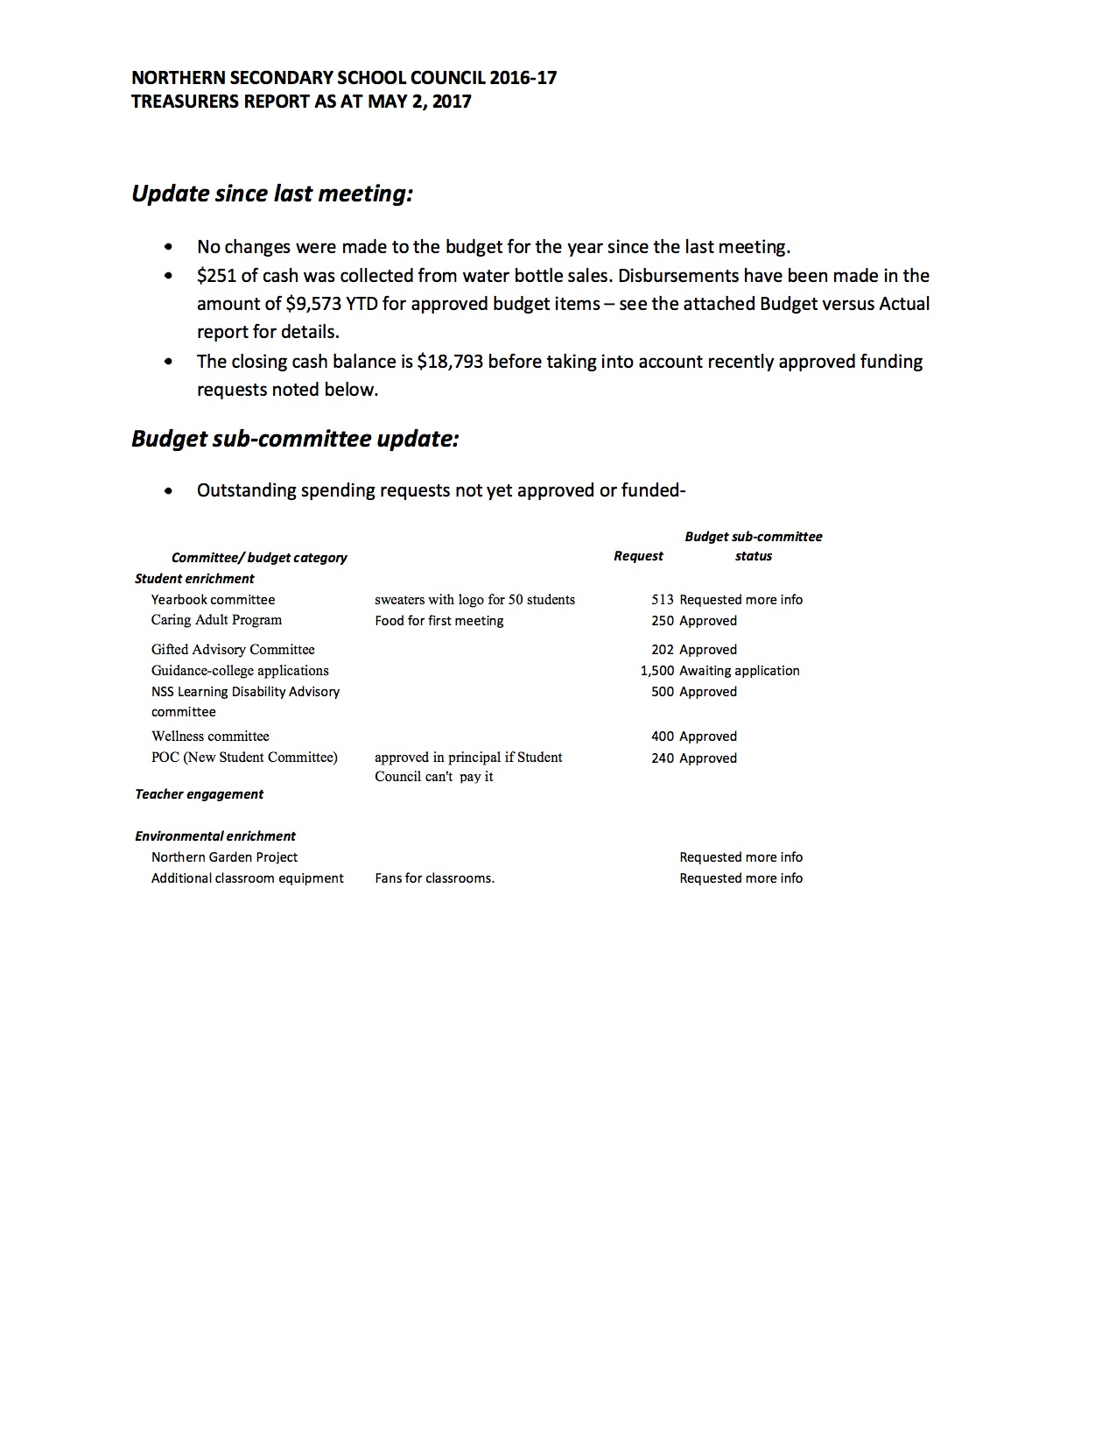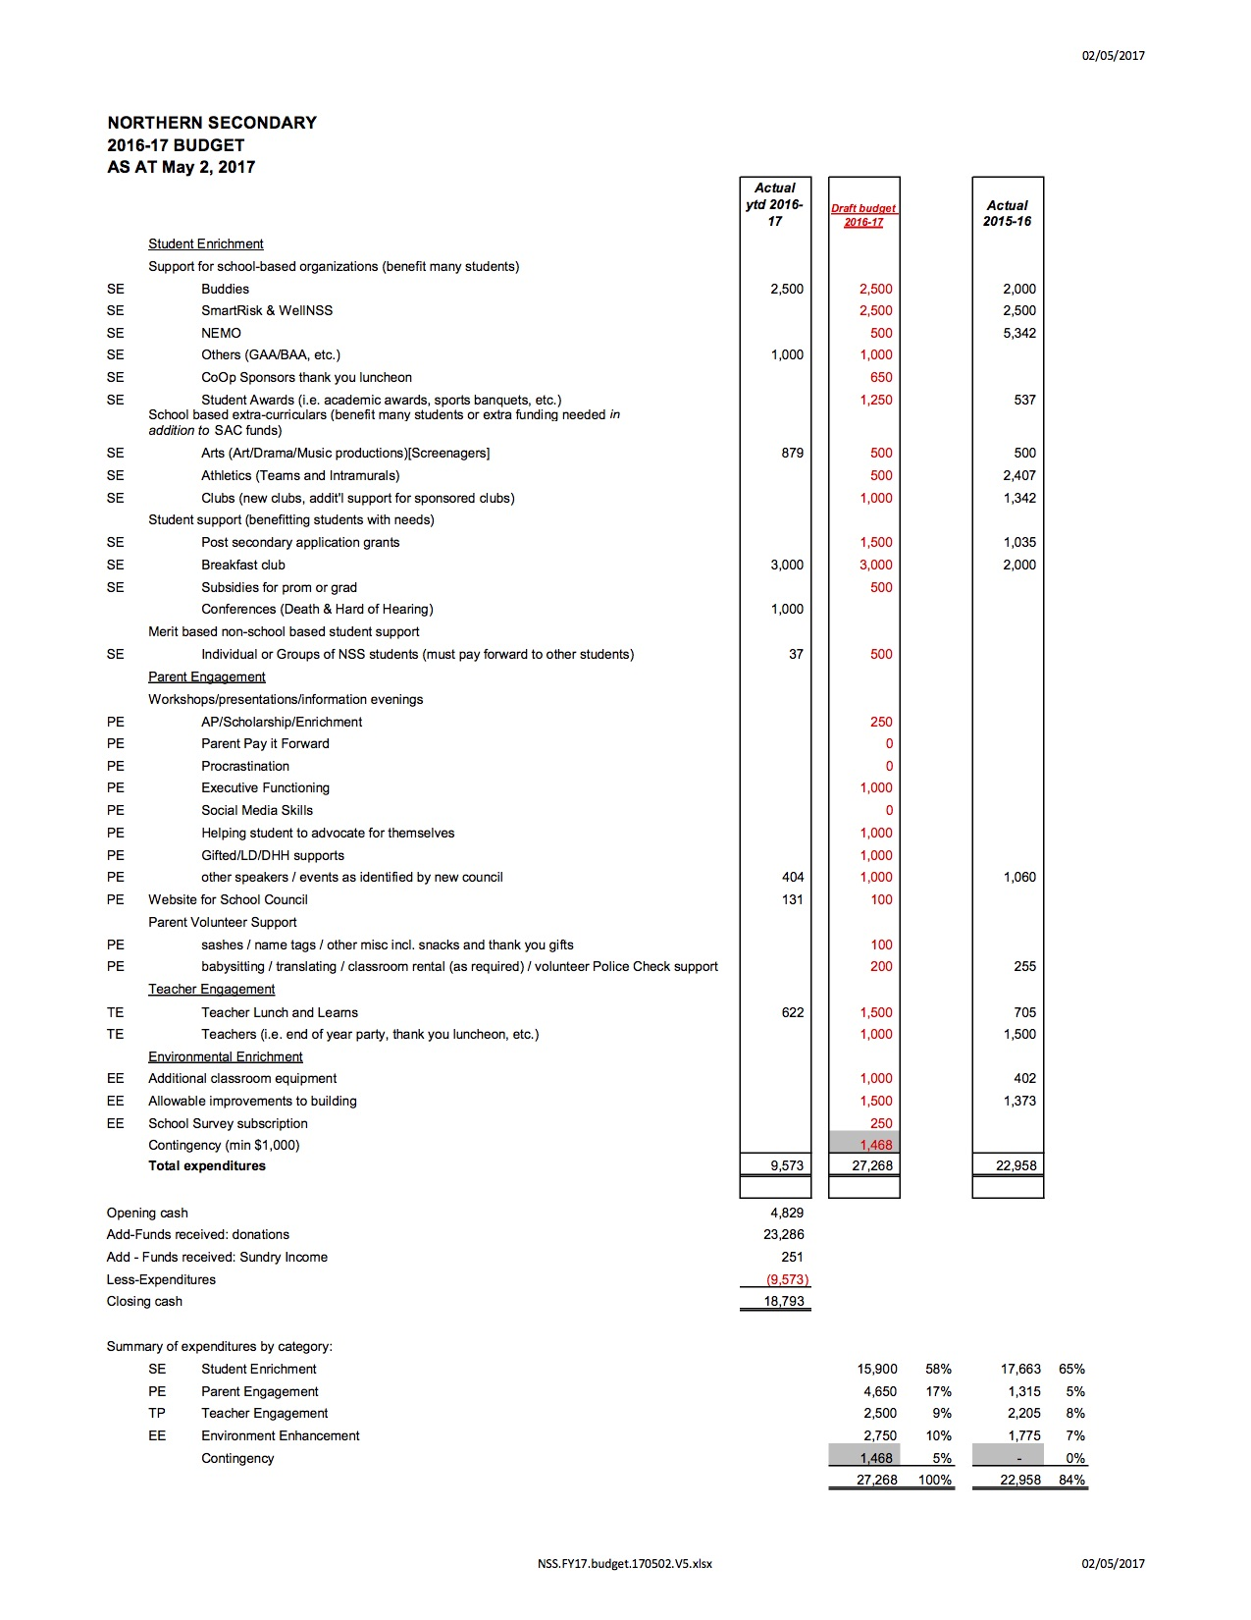  - Budget Committee approved expenditure for classroom fans. | Kasi
Cellphone Committee | - Committee received more than 1000 responses to survey from parents, teachers and students. Will meet on Wednesday to plan report summarizing results and making recommendations. | Scott
Eco Committee | - Working with a few members to generate ideas.  - Water bottle accounting to be clarified. | Bettina read email from Ms. Kinclova
Wellbeing Committee & PRO Grant | - Putting in PRO grant application for presentation on teenagers, technology & distraction. Currently researching appropriate speaker.  - Was advised cannot proceed with funding teachers to complete mental health first aid course because against TDSB rules.  - Bettina advised that Sashbear can provide 1 hour free presentation to kids on handling emotional dysregulation. Revisit idea in Fall because too late in school year to pursue. | Tanya
Learning Disabilities Committee | - Hoping to engage speaker for next year to present on executive functioning, anxiety and assistive devices.  - Will attend Grade 8 Welcome evening on June 1.  - Quiet lunchroom (rm 112) will remain operational until next Xmas then evaluate. | Shellie
Gifted Advisory Committee | - Motion re size of Northern gifted program sent to Supervising Principal of Special Education in Regions 1 and 4. Meeting on May 3 to discuss next steps. | Peggy
Welcome Committee | - No report provided.
Breakfast Committee | - Has put in funding request for next year. | Bettina (for Barb)
Caring & Safe Schools Committee | - Purchase of fans in progress.  - Suspensions and major problems down since beginning of school year. | VP Marshall
Other Business | - Student wants to start Social Club for kids to improve social skills next year. Advised to follow school procedure re Charter and funding.  - Raised issue about safety of asbestos in school. Was advised that TDSB investigated and concluded asbestos should remain in place as no significant harm and removal could be dangerous. Ms. Marr to advise if official report can be shared with Council & students. | Fabian Sekora
Teacher & Staff Report | - Staff to provide measurements for blinds. Council can purchase blinds but TDSB must install.  - Funding request for plants deferred to next year given upcoming vacation months. | Ms. Marr, Ms. Mathews, Mr. Banjovic
Student’s Report | - No report provided.
Community Member’s Report | - Attended Parents as Partners conference and met with Michelle Munroe, Central Coordinator PIAC. Ms. Munroe was invited to attend a Council meeting, but so far no response. This could be something to follow up on next year.  - Attended presentation by Jason Shaul Ellenbogen on communication between parents and teenagers.  - Brief discussion about John Fisher condo tower issue. Trustee Matlow setting up meeting to discuss community concerns and risk assessment.  - Province committed $1.4 billion to repair schools in latest budget. | Behzad
Vice Principal’s Report | - May 4: blood clinic at North Toronto.  - May 5: Prom. Valedictorian will be announced on May 3. School will hold Assembly in advance of Prom to discuss students’ responsibilities before and during the event.  - May 10: Tunescape concert  - May 11: Northern Lights art exhibit  - May 12: SAC election. School will hold Assembly on May 8 for election speeches.  - May 19: SAC Stock with extended lunch & activities  - June 1: Grade 8 Welcome night  - During culminating events, any absences/missed assignments require a medical note.  - School has 2.5 teacher surplus for next year. Overall, staff are down 7 positions. Currently sitting at 1768 students. Projection for next year is same. Gifted is down and optional attendance is up. Expect to run 4 gifted Grade 9 classes (31 each) next year.  - SRO program may be revisited given TDSB Director of Education John Molloy’s comments at recent meeting.  - Brief discussion about police safety alerts and communication to parents. Police communicate alerts to school and school decides whether or not to tell parents depending on circumstances. | VP Marshall
Co-Chairs Report | - (In camera discussion regarding a proposal was held and agreed)  - Metrolinx looking for members of the community to join their construction liason committee. It’s a 12-18 month commitment with monthly meetings. Send email to sc.northernsecondaryschool@tdsb.on.ca if interested.  - Ward forum on Equity May 15 at John Polyani Collegiate at 6:30 p.m. to discuss framework TDSB is developing.  - Looking for 1 or 2 volunteers to run Election Committee next Fall. Candidates cannot seek executive position (Chair, Treasurer, Secretary) themselves. Send email to sc.northernsecondaryschool@tdsb.on.ca if interested.  - Question about next meeting date conflicting with G8 Welcome.  - Parent volunteers are welcome at Grade 8 Welcome evening on June 1 at 5:00 p.m. Just show up.  - Committees are asked to submit meeting dates for next year to Council. | Bettina & Scott  Moved by: Bettina  2nd by: Behzad  Carried
Adjournment | - Motion to adjourn meeting at 8:20 p.m. Next meeting date Thursday, June 1, 7:00 – 8:30 p.m. (after G8 welcome night). | Moved by: Bettina  2nd by: Sue  Carried

For any questions, please contact School Council at SC.NorthernSecondarySchool@tdsb.on.ca

For Follow Up:

- Ms. Marr to advise if TDSB report on asbestos at Northern can be shared with Council and students.
- Parent volunteers for G8 welcome night please come to NSS Foyer a little before 5:00 on June 1.

