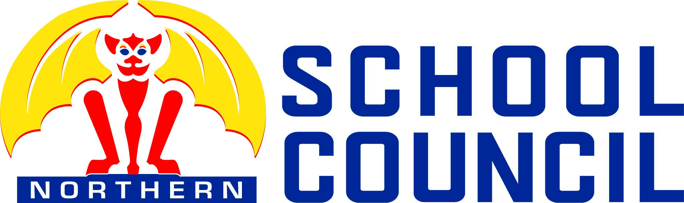

School Council Meeting

6:30-8:00 p.m.

Tuesday, October 8th, 2024

Northern Secondary School Library

**DRAFT AGENDA**

1. Welcome and Introductions - Election Committee

* 1. Land acknowledgement
  2. Approval of the agenda

2. Voting Process

3. Introduction of candidates for parent membership

4. Election of 15 Voting Members

5. Open floor - parent ideas and concerns for the year ahead while votes are counted

6. Introduction of candidates for executive positions

7. Election of Executive Positions

8. Onboarding of new members

9. Committee meet and greet

10. Discussion of the Process for the Selection of one Community Representative

11. Adjournment

## **2024-25 Meeting Dates – 6:30 pm – 8 pm School Library/Teams**

Tuesday, October 8, 2024 (elections only)

Tuesday, October 22, 2024

Thursday, November 21, 2024

Thursday, January 16, 2025

Tuesday, February 11, 2025

Thursday, April 3, 2025

Thursday, May 22, 2025